Objective Questions

- Does any table have missing values or duplicates? If yes, how would you handle it?

Ans:
Yes, there were a few missing values in the dataset like: -
- 49 company, 29 state, 47 fax values are null in the customer table.
- 1 reports to value is null in the employee table.
- 978 composer values are null in the track table.
There are no duplicate values in the whole dataset. In case of null values I would use COALESCE function to handle the situation
----------------------------------------------------------------------------------------------------------------

- Find the top-selling tracks and top artist in the USA and identify their most famous genres.

SQL Query:-
SELECT Top_selling_track, Top_artist, Top_genre FROM
(
SELECT t.name Top_selling_track, a.name Top_artist, g.name Top_genre, SUM(t.unit_price * il.quantity) FROM track t
LEFT JOIN invoice_line il on t.track_id = il.track_id
LEFT JOIN invoice i on i.invoice_id = il.invoice_id
LEFT JOIN album al on al.album_id = t.album_id
LEFT JOIN artist a on a.artist_id = al.artist_id
LEFT JOIN genre g on g.genre_id = t.genre_id
WHERE billing_country = "USA"
GROUP BY t.name, a.name, g.name
ORDER BY SUM(total) DESC
LIMIT 10
) Agg_table;

OUTPUT: -
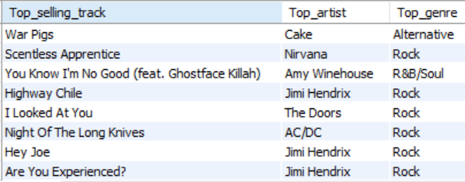
Therefore, the top genre in USA is Rock.

----------------------------------------------------------------------------------------------------------------

- What is the customer demographic breakdown (age, gender, location) of Chinook's customer base?

SQL Query:-
SELECT city, country, COUNT(customer_id) FROM customer
GROUP BY 1,2
ORDER BY country;

SELECT country, COUNT(customer_id) FROM customer
GROUP BY 1
ORDER BY 1;

SELECT COUNT(distinct country) FROM customer;

OUTPUT: -

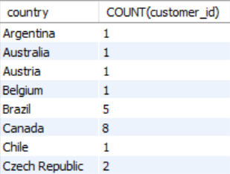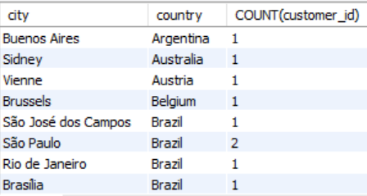
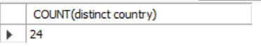
- The Customer Demographic Breakdown based on location is very diversified.
- The Chinook's customer base is spread over 24 countries with max number of customers from USA.
- The customer table does not have age and gender columns to understand the customer breakdown
----------------------------------------------------------------------------------------------------------------

- Calculate the total revenue and number of invoices for each country, state, and city:

SQL Query:-
SELECT billing_city, billing_state, billing_country, COUNT(invoice_id) num_of_invoices, SUM(total) total_revenue FROM invoice
GROUP BY 1,2,3
ORDER BY COUNT(invoice_id) DESC, SUM(total) DESC
OUTPUT: -

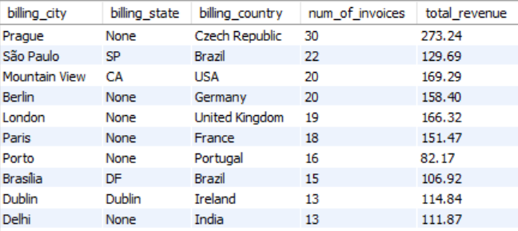

----------------------------------------------------------------------------------------------------------------

- Find the top 5 customers by total revenue in each country

SQL Query:-
WITH CustomerRevenue AS (
SELECT
c.country,
c.first_name,
c.last_name,
SUM(t.unit_price * il.quantity) AS total_revenue
FROM customer c
LEFT JOIN invoice i ON i.customer_id = c.customer_id
LEFT JOIN invoice_line il ON il.invoice_id = i.invoice_id
LEFT JOIN track t ON t.track_id = il.track_id
GROUP BY c.country, c.first_name, c.last_name
),
RankedCustomers AS (
SELECT
country,
first_name,
last_name,
RANK() OVER (PARTITION BY country ORDER BY total_revenue DESC) AS rk
FROM CustomerRevenue
)
SELECT
country,
first_name,
last_name
FROM RankedCustomers
WHERE rk <= 5
ORDER BY country, rk;
OUTPUT: -
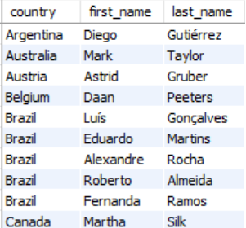
----------------------------------------------------------------------------------------------------------------

- Identify the top-selling track for each customer

SQL Query:-
SELECT first_name, last_name, t.name Track_name, SUM(quantity) Total_quantity FROM customer c
LEFT JOIN invoice i on i.customer_id = c.customer_id
LEFT JOIN invoice_line il on il.invoice_id = i.invoice_id
LEFT JOIN track t on t.track_id = il.track_id
GROUP BY 1,2,3
ORDER BY SUM(quantity) DESC;
OUTPUT: -
The customers had similar quantity of different tracks. So its was difficult to select one as the top track for each customer.
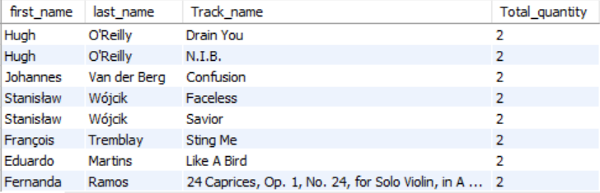

----------------------------------------------------------------------------------------------------------------

- Are there any patterns or trends in customer purchasing behavior (e.g., frequency of purchases, preferred payment methods, average order value)?

SQL Query:-
SELECT customer_id, COUNT(invoice_id) num_invoices, AVG(total) avg_sales FROM invoice
GROUP BY 1
ORDER BY COUNT(invoice_id) DESC, AVG(total) DESC

No there is no correlation or trend between the number/frequency of orders by different customers and the average sales generated by these customers. The average sales most probably depend on the unit price of each track and not the number of orders.
----------------------------------------------------------------------------------------------------------------

- What is the customer churn rate?
SQL Query:-
WITH num_cust_in_1st_3months as
(
SELECT COUNT(customer_id) ttl from invoice
WHERE invoice_date BETWEEN '2017-01-01' AND '2017-03-31'
),
(
SELECT COUNT(customer_id) l_num FROM invoice
WHERE invoice_date BETWEEN '2020-11-01' AND '2020-12-31'
)
SELECT ((SELECT ttl FROM num_cust_in_1st_3months)-(SELECT l_num FROM num_cust_in_last_2months))/(SELECT ttl FROM num_cust_in_1st_3months) * 100 as churn_rate
;

OUTPUT: -
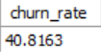

The customer churn rate is approximately 40.82%, calculated based on the number of customers in the first 3 months (49) and the number retained in the last 2 months (29).

Customers lost = 49 - 29 = 20
Churn Rate = (20 / 49) × 100 ≈ 40.82%

This indicates that the company lost over 40% of its customers during the observed period.

----------------------------------------------------------------------------------------------------------------

- Calculate the percentage of total sales contributed by each genre in the USA and identify the best-selling genres and artists.
SQL Query:-
WITH usa_revenue AS (
SELECT SUM(total) AS total_revenue_usa
FROM invoice
WHERE billing_country = 'USA'
),
genre_revenue AS (
SELECT
g.genre_id,
g.name AS genre_name,
SUM(t.unit_price * il.quantity) AS genre_revenue
FROM track t
JOIN genre g ON g.genre_id = t.genre_id
JOIN invoice_line il ON il.track_id = t.track_id
JOIN invoice i ON i.invoice_id = il.invoice_id
WHERE i.billing_country = 'USA'
GROUP BY g.genre_id, g.name
),
genre_ranking AS (
SELECT
gr.genre_id,
gr.genre_name,
ROUND(gr.genre_revenue / ur.total_revenue_usa * 100, 2) AS percentage_contribution,
DENSE_RANK() OVER (ORDER BY gr.genre_revenue DESC) AS rk
FROM genre_revenue gr
CROSS JOIN usa_revenue ur
),
final_result AS (
SELECT
gr.genre_id,
gr.genre_name,
a.name AS artist_name,
gr.percentage_contribution,
gr.rk
FROM genre_ranking gr
JOIN track t ON t.genre_id = gr.genre_id
JOIN album al ON al.album_id = t.album_id
JOIN artist a ON a.artist_id = al.artist_id
)
SELECT
genre_id,
genre_name,
artist_name,
percentage_contribution,
rk
FROM final_result
GROUP BY genre_id, genre_name, artist_name, percentage_contribution, rk
ORDER BY rk, genre_name, artist_name;
OUTPUT: -
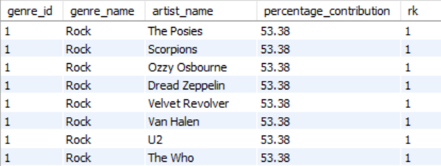

Therefore the top selling genre in USA is Rock.
The Posies, Scorpions, Ozzy Osbourne, Dread Zeppelin, Velvet Revolver, Van Halen, U2, The Who, The Rolling Stones, The Police, The Doors, The Cult, Terry Bozzio, Tony Levin & Steve Stevens, Stone Temple Pilots, Soundgarden, Skank, Lenny Kravitz, Santana, Rush, Red Hot Chili Peppers, Raul Seixas, R.E.M., Queen, Pink Floyd, Pearl Jam, Paul D'Ianno, Page & Plant, O Terço, Nirvana, Men At Work, Marillion, Led Zeppelin, Kiss, Joe Satriani, Jimi Hendrix, Jamiroquai, Iron Maiden, Guns N' Roses, Foo Fighters, Faith No More, Def Leppard, Deep Purple, Creedence Clearwater Revival, David Coverdale, Frank Zappa & Captain Beefheart, Audioslave, Alice In Chains, Alanis Morissette, Aerosmith, AC/DC, Accept are all the top artists who are associated with the Rock genre.

----------------------------------------------------------------------------------------------------------------

- Find customers who have purchased tracks from at least 3 different genres

SQL Query:-
SELECT name_of_customer FROM
(
SELECT CONCAT(first_name, ' ', last_name) name_of_customer, COUNT(DISTINCT g.name) FROM customer c
LEFT JOIN invoice i on i.customer_id = c.customer_id
LEFT JOIN invoice_line il on il.invoice_id = i.invoice_id
LEFT JOIN track t on t.track_id = il.track_id
LEFT JOIN genre g on g.genre_id = t.genre_id
GROUP BY 1 HAVING COUNT(DISTINCT g.name) >= 3
ORDER BY COUNT(DISTINCT g.name) DESC
) agg_table

OUTPUT: -
Leonie Köhler is the person who has bought tracks from 14 different genres.

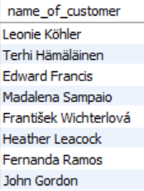

----------------------------------------------------------------------------------------------------------------

- Rank genres based on their sales performance in the USA
SQL Query:-
WITH cte as
(
SELECT t.genre_id, g.name, SUM(t.unit_price * il.quantity) sale_performance FROM track t
LEFT JOIN genre g on g.genre_id = t.genre_id
LEFT JOIN invoice_line il on il.track_id = t.track_id
LEFT JOIN invoice i on i.invoice_id = il.invoice_id
WHERE billing_country = 'USA'
GROUP BY 1, 2
)
SELECT name, sale_performance,
DENSE_RANK() OVER(ORDER BY sale_performance DESC) `rank` FROM cte
;

OUTPUT: -

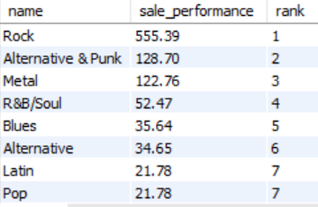

----------------------------------------------------------------------------------------------------------------

- Identify customers who have not made a purchase in the last 3 months
SQL Query:-

WITH last_3_months as
(
SELECT * from invoice
WHERE invoice_date > (SELECT MAX(invoice_date) FROM invoice) - INTERVAL 3 MONTH
)
SELECT CONCAT(first_name, ' ', last_name) name_of_customer FROM customer c
LEFT JOIN last_3_months lm on lm.customer_id = c.customer_id
WHERE invoice_id is NULL

OUTPUT: -
There are 22 customers in the dataset who have not made any purchase in the last 3 months.
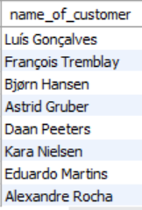
----------------------------------------------------------------------------------------------------------------

Subjective Questions

- Recommend the three albums from the new record label that should be prioritised for advertising and promotion in the USA based on genre sales analysis.
WITH genre_sales as
(
SELECT g.genre_id, g.name, sum(t.unit_price * il.quantity) total_revenue_for_genre FROM track t
LEFT JOIN genre g on g.genre_id = t.genre_id
LEFT JOIN invoice_line il on il.track_id = t.track_id
LEFT JOIN invoice i on i.invoice_id = il.invoice_id
WHERE billing_country = 'USA'
GROUP BY 1,2
ORDER BY total_revenue_for_genre DESC
),
ranking as
(
SELECT genre_id, name, total_revenue_for_genre,
DENSE_RANK() OVER(ORDER BY total_revenue_for_genre DESC) rk FROM genre_sales
),
genre_album as
(
SELECT ranking.genre_id, ranking.name genre_name, al.title album_name FROM ranking
LEFT JOIN track t on t.genre_id = ranking.genre_id
LEFT JOIN album al on al.album_id = t.album_id
LEFT JOIN artist a on a.artist_id = al.artist_id
WHERE rk = 1
GROUP BY 1,2,3
),
best_album as
(
SELECT al.album_id, title, SUM(t.unit_price * il.quantity) FROM album al
LEFT JOIN track t on t.album_id = al.album_id
LEFT JOIN invoice_line il on il.track_id = t.track_id
GROUP BY 1,2
ORDER BY SUM(t.unit_price * il.quantity) desc
)
SELECT genre_id, genre_name, album_name FROM genre_album
inner join best_album on best_album.title = genre_album.album_name
LIMIT 3
Approach:
First, the most popular genre was found using the first query. The second query was then used to retrieve the albums in that genre along with their reach and total sales.

Insights:
- Some albums have high total sales with relatively lower reach (distinct customers). Also, these albums are from the most popular genre: Rock. So, there is less chance that the lesser reach could mean ‘a unique, lesser, specific cult audience.’ These albums should be promoted.

Recommendations:
The 3 albums that should be promoted or advertised in the USA are:
- Hot Rocks, 1964-1971 (Disc 1),
- The Best Of Van Halen, Vol. I
- Live On Two Legs [live].

----------------------------------------------------------------------------------------------------------------

- Determine the top-selling genres in countries other than the USA and identify any commonalities or differences.
SELECT g.genre_id, g.name, sum(t.unit_price * il.quantity) total_revenue_for_genre FROM track t
LEFT JOIN genre g on g.genre_id = t.genre_id
LEFT JOIN invoice_line il on il.track_id = t.track_id
LEFT JOIN invoice i on i.invoice_id = il.invoice_id
WHERE billing_country != 'USA'
GROUP BY 1,2
ORDER BY total_revenue_for_genre DESC

Visualisation

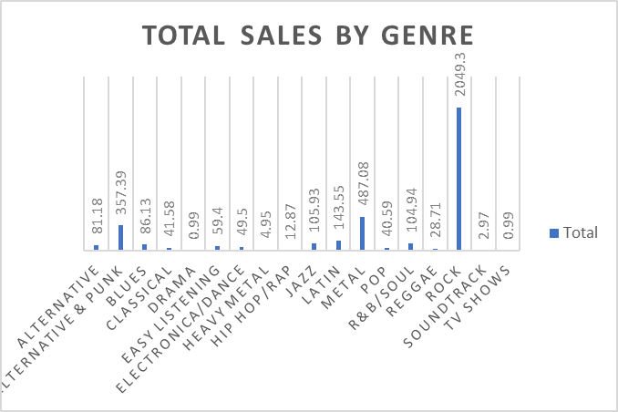

Approach:
Earlier, the query to retrieve genre names along with total sales in the USA was used. Now, the same was done for outside the USA.

Insights:
Similarities:
- The top 3 genres in the USA and outside USA are Rock, Metal and Alternative & Punk.
- Rock is clearly the most popular genre in both USA and outside the USA with a massive lead in sales.
- The top 10 genres in both the USA and outside the USA have some common genres too, like Latin, Jazz, R&B/Soul, Blues.

Differences:
- Metal is rank 2 outside the USA but Alternative & Punk is rank 2 in the USA
- R&B/Soul and Blues are sold more in the USA, while Latin and Jazz are sold more outside America
- Hip Hop is in the top ten most sold genres in the Unites States but it is outside the top ten outside the United States.

Recommendations:
- Artists, albums and tracks from Rock, Metal, Alternative & Punk should be advertised both inside and outside America.
- Outside America, Latin and Jazz should be promoted more.

----------------------------------------------------------------------------------------------------------------

- Customer Purchasing Behavior Analysis: How do the purchasing habits (frequency, basket size, spending amount) of long-term customers differ from those of new customers? What insights can these patterns provide about customer loyalty and retention strategies?
-- Step 1: Calculate individual customer metrics
WITH customer_metrics AS (
SELECT
i.customer_id,
MAX(i.invoice_date) AS last_purchase,
MIN(i.invoice_date) AS first_purchase,
ABS(TIMESTAMPDIFF(MONTH, MAX(i.invoice_date), MIN(i.invoice_date))) AS duration_months,
SUM(i.total) AS total_sales,
SUM(il.quantity) AS total_items,
COUNT(i.invoice_id) AS purchase_frequency
FROM invoice i
JOIN invoice_line il ON il.invoice_id = i.invoice_id
GROUP BY i.customer_id
),

-- Step 2: Calculate average duration for categorization
average_duration AS (
SELECT AVG(duration_months) AS avg_duration
FROM customer_metrics
),
-- Step 3: Categorize customers
categorized_customers AS (
SELECT
cm.*,
CASE
WHEN cm.duration_months > ad.avg_duration THEN 'Long-term Customer'
ELSE 'Short-term Customer'
END AS category
FROM customer_metrics cm
CROSS JOIN average_duration ad
)
-- Step 4: Aggregate by category
SELECT
category,
SUM(total_sales) AS total_spending,
SUM(total_items) AS basket_size,
COUNT(customer_id) AS customer_count
FROM categorized_customers
GROUP BY category;
Visualisation

Approach:
The query was used to retrieve total number of customers, total purchases, total revenue, average lifetime spending, average order value, average basket size and average purchase frequency per customer. All the customers are long term customers.

Insights:
- For all the total customers (59), here is the purchasing behavior:
Total Purchases: 4745
Total Revenue: 47398.23
Average Life Time Spending Per Customer: 803.36
Average Order Value Per Invoice: 9.99
Average Basket Size Per Invoice: 1.00
Average Purchase Frequency Per Customer: 80.42

Recommendations:
- Initiatives should be taken to increase the reach (total number of distinct customers)
- In countries where the total number of customers is very low, extra points should be given for referrals.

----------------------------------------------------------------------------------------------------------------

- Product Affinity Analysis: Which music genres, artists, or albums are frequently purchased together by customers? How can this information guide product recommendations and cross-selling initiatives?
WITH cte as
(
SELECT invoice_id, COUNT(DISTINCT g.name) num FROM invoice_line il
left JOIN track t on t.track_id = il.track_id
left JOIN genre g on g.genre_id = t.genre_id
GROUP BY 1 HAVING COUNT(DISTINCT g.name) > 1
)
SELECT cte.invoice_id, num, g.name FROM cte
left join invoice_line il on il.invoice_id = cte.invoice_id
left JOIN track t on t.track_id = il.track_id
left JOIN genre g on g.genre_id = t.genre_id
GROUP BY 1,2,3;

WITH cte as
(
SELECT invoice_id, COUNT(DISTINCT al.title) num FROM invoice_line il
left JOIN track t on t.track_id = il.track_id
left JOIN album al on al.album_id = t.album_id
GROUP BY 1 HAVING COUNT(DISTINCT al.title) > 1
)
SELECT cte.invoice_id, num, al.title FROM cte
left join invoice_line il on il.invoice_id = cte.invoice_id
left JOIN track t on t.track_id = il.track_id
left JOIN album al on al.album_id = t.album_id
GROUP BY 1,2,3;

WITH cte as
(
SELECT invoice_id, COUNT(DISTINCT a.name) num FROM invoice_line il
left JOIN track t on t.track_id = il.track_id
left JOIN album al on al.album_id = t.album_id
left join artist a on a.artist_id = al.artist_id
GROUP BY 1 HAVING COUNT(DISTINCT a.name) > 1
)
SELECT cte.invoice_id, num, a.name FROM cte
left join invoice_line il on il.invoice_id = cte.invoice_id
left JOIN track t on t.track_id = il.track_id
left JOIN album al on al.album_id = t.album_id
left join artist a on a.artist_id = al.artist_id
GROUP BY 1,2,3;

Approach:
The queries were used to retrieve the maximum number of times artists, tracks, albums were bought together. We specifically get top ten times they were bought together.
Insigths:
- The highest frequency of a genre being purchased together with another genre is Rock with Rock.

- Just like that, Metal is sold with Metal and Alternative & Punk with Alternative & Punk. However, the frequency is way less than Rock with Rock.

- Rock is also purchased with Alternative & Punk and Metal.

- Speaking of artist affinity and album affinity, the top ten number of times when two artists or two albums were bought together, artist 1 and artist 2 were the same artist. And so was the case with album 1 and album 2.

Recommendations:

- The highest frequency of a genre being purchased together with another genre is Rock with Rock. So, cross-selling initiatives should be taken in this genre. More and more Rock tracks should be recommended /cross sold to people who people who buy Rock tracks together. They should be introduced to new artists, albums and tracks. More tracks should be sold on discounted prices.

- Just like that, Metal is sold with Metal and Alternative & Punk with Alternative & Punk. However, the frequency is way less than Rock with Rock. So, to those who buy these genres together, more tracks should be recommended in the same genre, and incentives should be given (discounted prices).

- Rock is also purchased with Alternative & Punk and Metal. So, Rock tracks should also be recommended to customers who buy Alternative & Punk and Metal, since Rock is a very popular genre.

- Speaking of artist affinity and album affinity, the top ten number of times when two artists or two albums were bought together, artist 1 and artist 2 were the same artist. And so was the case with album 1 and album 2. So, if a customer buys tracks from the same artist together, other tracks/albums of that artist should be recommended. If tracks from the same album are bought, the entire album should be sold at a discounted price.

----------------------------------------------------------------------------------------------------------------

- Regional Market Analysis: Do customer purchasing behaviors and churn rates vary across different geographic regions or store locations? How might these correlate with local demographic or economic factors?
Scroll to see all query
WITH num_cust_in_1st_3months as
(
SELECT billing_country, COUNT(customer_id) ttl from invoice
WHERE invoice_date BETWEEN '2017-01-01' AND '2017-03-31'
GROUP BY 1
),
num_cust_in_last_2months as
(
SELECT billing_country, COUNT(customer_id) l_num FROM invoice
WHERE invoice_date BETWEEN '2020-11-01' AND '2020-12-31'
GROUP BY 1
)
SELECT n1.billing_country, (ttl - COALESCE(l_num,0))/ttl * 100 churn_rate FROM num_cust_in_1st_3months n1
LEFT JOIN num_cust_in_last_2months n2 on n1.billing_country = n2.billing_country
;

WITH num_cust_in_1st_3months as
(
SELECT billing_city, COUNT(customer_id) ttl from invoice
WHERE invoice_date BETWEEN '2017-01-01' AND '2017-03-31'
GROUP BY 1
),
num_cust_in_last_2months as
(
SELECT billing_city, COUNT(customer_id) l_num FROM invoice
WHERE invoice_date BETWEEN '2020-11-01' AND '2020-12-31'
GROUP BY 1
)
SELECT n1.billing_city, (ttl - COALESCE(l_num,0))/ttl * 100 churn_rate FROM num_cust_in_1st_3months n1
LEFT JOIN num_cust_in_last_2months n2 on n1.billing_city = n2.billing_city
;

WITH num_cust_in_1st_3months as
(
SELECT billing_state, COUNT(customer_id) ttl from invoice
WHERE invoice_date BETWEEN '2017-01-01' AND '2017-03-31'
GROUP BY 1
),
num_cust_in_last_2months as
(
SELECT billing_state, COUNT(customer_id) l_num FROM invoice
WHERE invoice_date BETWEEN '2020-11-01' AND '2020-12-31'
GROUP BY 1
)
SELECT n1.billing_state, (ttl - COALESCE(l_num,0))/ttl * 100 churn_rate FROM num_cust_in_1st_3months n1
LEFT JOIN num_cust_in_last_2months n2 on n1.billing_state = n2.billing_state
;

SELECT billing_country, COUNT(invoice_id) num_invoices, AVG(total) avg_sales FROM invoice
GROUP BY 1
ORDER BY COUNT(invoice_id) DESC, AVG(total) DESC
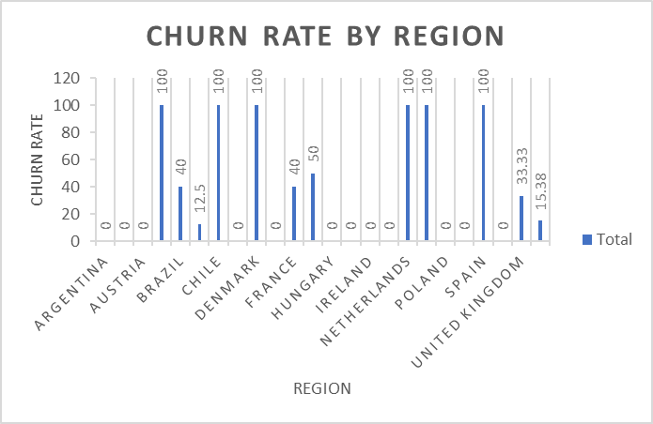

Insights: -
The customer churn rate shows noticeable variation across different countries, cities, and states.
Additionally, customer purchasing behaviour differs significantly by geography, indicating region-specific preferences and engagement patterns.

Recommendations: -
Data suggests that developed countries contribute a higher number of orders and greater average sales,
highlighting the influence of economic strength on purchasing power.

----To optimize sales:
**Increase targeted advertising in high-income countries to maximize revenue potential.
**Offer more affordable track pricing or localized discounts in lower-income countries to boost accessibility and sales.
**Population size should also be considered when evaluating market potential, as it directly impacts the customer base and potential revenue volume in a given region.

----------------------------------------------------------------------------------------------------------------

- Customer Risk Profiling: Based on customer profiles (age, gender, location, purchase history), which customer segments are more likely to churn or pose a higher risk of reduced spending? What factors contribute to this risk?
SELECT i.customer_id, CONCAT(first_name, " ", last_name) name, billing_country, invoice_date, SUM(total) total_spending, COUNT(invoice_id) num_of_orders FROM invoice i
LEFT JOIN customer c on c.customer_id = i.customer_id
GROUP BY 1,2,3,4
ORDER BY name

Visualisation: 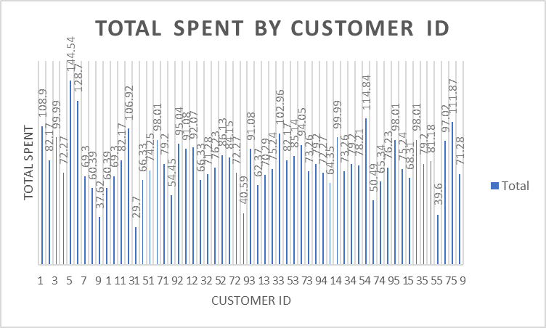

Insights: -

Analysis of the sales data through charts and tables reveals a trend where countries already exhibiting high spending and frequent orders continue to grow,
while sales and frequency remain stagnant in other regions. This indicates a regional imbalance in engagement and retention.

Additionally, a lack of demographic data limits the depth of churn and behavioral analysis.
If available, key factors that could contribute to customer churn risk include:

- Age: Are younger customers more likely to churn?
- Gender: Does gender influence retention and spending patterns?
- Location: Are certain cities, states, or countries more prone to churn?
- Spending Behavior: How do high-spending, loyal customers compare to low-frequency or low-spending buyers?

Recommendations: -

- To mitigate churn and boost engagement in underperforming regions:
- Launch targeted promotional campaigns in countries with stagnant sales to re-engage existing customers and attract new ones.
- Use geographic segmentation to customize marketing efforts based on regional performance.

Once demographic data is available, implement customer segmentation models such as:

Young Male – High Spenders
Young Female – High Spenders
Older Male – Low Spenders
Older Female – Low Spenders

These segments would allow for more personalized engagement strategies and retention efforts, ultimately driving revenue and reducing churn across different customer profiles.

----------------------------------------------------------------------------------------------------------------

- Customer Lifetime Value Modeling: How can you leverage customer data (tenure, purchase history, engagement) to predict the lifetime value of different customer segments? This could inform targeted marketing and loyalty program strategies. Can you observe any common characteristics or purchase patterns among customers who have stopped purchasing?
WITH purchase_data AS (
SELECT
customer_id,
COUNT(invoice_id) AS total_purchases,
DATEDIFF(MAX(invoice_date), MIN(invoice_date)) AS total_days_between_first_last,
NULLIF(COUNT(invoice_id) - 1, 0) AS purchase_intervals,
SUM(total) AS total_spent,
ROUND(DATEDIFF(MAX(invoice_date), MIN(invoice_date)) / NULLIF(COUNT(invoice_id) - 1, 1), 2) AS avg_days_between_purchases,
MAX(invoice_date) AS last_order_date
FROM invoice
GROUP BY customer_id
),
customer_segments AS (
SELECT
p.customer_id,
p.total_purchases,
p.avg_days_between_purchases,
CASE
WHEN p.avg_days_between_purchases <= 180 THEN 'High Frequency'
WHEN p.avg_days_between_purchases BETWEEN 181 AND 280 THEN 'Moderate Frequency'
ELSE 'Low Frequency'
END AS purchase_frequency_segment,
p.total_spent,
CASE
WHEN p.total_spent >= 106.00 OR p.total_purchases >= 13 THEN 'High Value'
WHEN p.total_spent BETWEEN 68.00 AND 106.00 OR p.total_purchases BETWEEN 9 AND 13 THEN 'Moderate Value'
ELSE 'Low Value'
END AS spending_segment,
p.last_order_date,
CASE
WHEN p.last_order_date < DATE_SUB('2020-12-30', INTERVAL 6 MONTH) THEN 'Churned'
WHEN p.last_order_date BETWEEN DATE_SUB('2020-12-30', INTERVAL 6 MONTH) AND DATE_SUB('2020-12-30', INTERVAL 3 MONTH) THEN 'At Risk'
ELSE 'Active'
END AS churn_status
FROM purchase_data p
)
SELECT
customer_id,
total_purchases,
avg_days_between_purchases,
purchase_frequency_segment,
total_spent,
spending_segment,
last_order_date,
churn_status
FROM customer_segments;

Output:


Approach:

Customers were segmentized based on frequency (average days between purchases), total spent and total purchases (high value, low value and moderate value), and churn
status (active, churned, at risk).

Insights:

Most customers who are churned belong to the moderate value segment.
Customers belonging to the high value segment are usually active.

Most customers belong to the high frequency segment.
None of the customers belonging to the low frequency or moderate frequency segments are churned. This can be because buying after a lot of days made their latest order date in the past 6 months.

Recommendations:

- Most customers who are churned belong to the moderate value segment. For customers who have already churned, there should be win back discounts and exclusive deals.
- Customers belonging to the high value segment are usually active. There should be loyalty programs for these customers to keep them actively engaged and spending more. For example, a points system is a good idea.
- For the ‘at risk’ customers, retention strategies should be applied.
- Most customers belong to the high frequency segment. There should be deals, discounts and loyalty programs to keep this segment engaged.
- None of the customers belonging to the low frequency or moderate frequency segments are churned. This can be because buying after a lot of days made their latest order date in the past 6 months. However, incentives should be given to them to increase their frequency.

----------------------------------------------------------------------------------------------------------------

- If data on promotional campaigns (discounts, events, email marketing) is available, how could you measure their impact on customer acquisition, retention, and overall sales?

If the data on promotional campaigns was available, I would have used it to analyze its impact on
1. Customer Acquisition based on
• The increase in the number of customers with time.
• Number of people participating in the events held in different locations.
• The increase in click-through rate due to the email marketing campaigns.

2. Retention on the basis of
• Number of old customers attending the event and then purchasing the track again after long time.
• Number of customers getting a discount.

3. Sales on the basis of
• Increase in the sales due to promotional campaigns.
• Trends to analyse which promotional campaign was the best.
• New customers being generated due to discounts

----------------------------------------------------------------------------------------------------------------

- How would you approach this problem, if the objective and subjective questions weren't given?

If the objective and subjective questions weren’t given, I would have first gone through the aim of the project and based on that decide the KPIs which would have helped me reach the objective.
Then I would have developed various business questions like: -
• Which are locations from where maximum sale is coming?
• Which tracks are the best-selling in each location?
• Which are the most popular artists and albums in different regions?
• How is sales distributed among different countries?
• Which genre is most liked in each country?
& also look over the Trends in the purchases of tracks like: -
• What is the total revenue generated over a period of time?
• How is the invoice total of each customer changed with time?
• What is the trend of a particular genre in a particular country?
Then I would have summarized all the insights and presented the data.

----------------------------------------------------------------------------------------------------------------

- How can you alter the "Albums" table to add a new column named "ReleaseYear" of type INTEGER to store the release year of each album?

We can use the ALTER TABLE command to add a new column to the Album table.

Code: -
ALTER TABLE album
ADD ReleaseYear
data_type int;
----------------------------------------------------------------------------------------------------------------
- Chinook is interested in understanding the purchasing behavior of customers based on their geographical location. They want to know the average total amount spent by customers from each country, along with the number of customers and the average number of tracks purchased per customer. Write an SQL query to provide this information.
SELECT billing_country,
COUNT(DISTINCT customer_id) num_of_customers,
AVG(total) Average_total_amount,
COUNT(track_id) num_of_tracks
FROM invoice i
LEFT JOIN invoice_line il on il.invoice_id = i.invoice_id
GROUP BY 1
;

SELECT customer_id, COUNT(DISTINCT track_id) num_of_tracks_per_customer FROM invoice i
LEFT JOIN invoice_line il on il.invoice_id = i.invoice_id
GROUP BY 1

OUTPUT:-
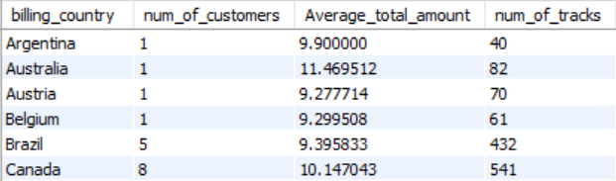

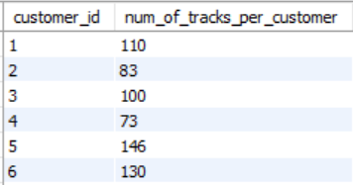

Approach:
The query was used to retrieve total customers, average tracks purchased per customer, average spent per customer by country.

Insights:

Czech Republic is the leader when it comes to both average total-amount spent by customers and average number of tracks purchased per customer.

Speaking of total number of customers, USA wins with 13 customers.

Recommendations:

The major issue seems to be only one customer in multiple countries. Referral incentives must be given to these customers and the store should be advertised to increase reach.

----------------------------------------------------------------------------------------------------------------

